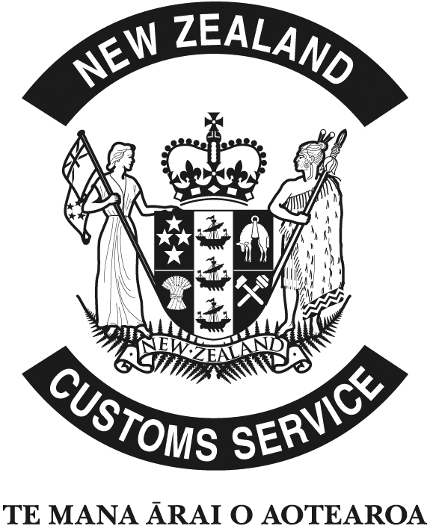
APPLICATION FOR CLIENT CODE
Fax to your local Customs office (Refer list of numbers overleaf)
For enquiries telephone: 0800 428786

Applicant is a:
Private individual Company Sole trader Partnership
Importer Exporter Other
Full Name of Applicant:
.. Date of birth: ..
.. Date of birth: ..
.. Date of birth: ..
Note: 1. "Limited" and company registration number must be shown where applicable. Copy of Certificate of Incorporation required as verification.
2. Full trading name and full names of all partners required for sole trader/partnerships.
3. Date of birth must be shown for private individuals/partnerships/sole traders. Copy of Drivers licence, Birth Certificate or Passport required as ID. For partnerships a copy of Partnership Agreement or copy of ID required for all partners.
IRD/GST number: .. | Company registration number: ..
Passport number & nationality: ..
Full street address: ..  ..  ..  .. | Full postal address: ..  ..  ..  ..
Phone number: .. | Fax number: ..
Contact person: .. | Mobile number: ..
Goods imported: ..

Signed:
(Note: For partnerships all signatures required)
To be completed if using a Customs Broker
I, .. , ..
Full name of signatory (above) Title
hereby authorise the New Zealand Customs Service to advise ..
of the client code allocated to me. Broker
Contact person: .. Brokers Fax: ..
For Customs Use
 | The new/existing code is:
Customs officer: .. |  | Date: ..
IMPORTANT: Please retain this code for future use.

Fax Numbers of Customs Offices

Auckland 09-359 6735
Christchurch 03-358 0607
Dunedin 03-477 6773
Invercargill 03-218 7328
Napier 06-835 1298
Nelson 03-546 9381
New Plymouth 06-758 1441
Tauranga 07-575 0522
Wellington 04-462 0155

